

**Day 8 :**

**Topic :**Introduction about visual studio editor and attach the college management application

**Milestones / Activities :**

Visual studio editor introduction and tools and chrome console command in javascript

**Detailed Description :**

**How To Use Visual Studio Code:**

Install Extensions in Visual Studio Code.

1. Salesforce CLI Integration
2. Salesforce Extension pack

Salesforce Extension pack consists of several extensions, all of which are published by Salesforce. The extension pack has the following extensions, as of now, which will be activated automatically when you install this pack.

**The Salesforce CLI Integration Extension Pack**

* Apex
* Visualforce
* Aura Components
* Apex Interactive Debugger
* Apex Replay Debugger
* Lightning Web Components

**College management application accesing in the visual studio**: To add files and access to the visual studio.



The application form and colleges and all you can access onto it.

In the visual studio code in left bar you can show the file names with college management application. In this you can access the apex classes and apex trigger codes.

**Lightning web components :**

Lightning Web Components (LWC) is a stack of modern lightweight frameworks built on the latest web standards. It is a DOM (Document Object Model), element created through reusable code and is used to generate a dynamic interface without using JavaScript or building a Library. This feasibility makes it quick and seamless, saving the developers a ton of time and effort on the Web Stack. Let’s look at some of its remarkable features:

* Improved performance of the component as most of the code is recognized by the native web browser engine and web stack
* Ability to compose applications using smaller chunks of code since the crucial elements that are required to create a component is part of the native web browser engine and web stack
* Increase in the robustness of the applications built using LWCs as they are inclusive of the said modern web standards.
* Parallel interoperability and feasibility to use both Lightning Web Components and Aura components together in the applications with no visible differentiation to the end-users

Uses of the lightning web components :

If your organization is already using Aura-based lightning components and the development team is highly skilled with the Aura framework, here’s the good news — the Aura Framework is not going anywhere. However, LWCs are the future of lightning development.



**Screenshots of Milestones / Activities :**

In visual studio to download the salesforce extension pack :







Connect the organization to the visual studio :



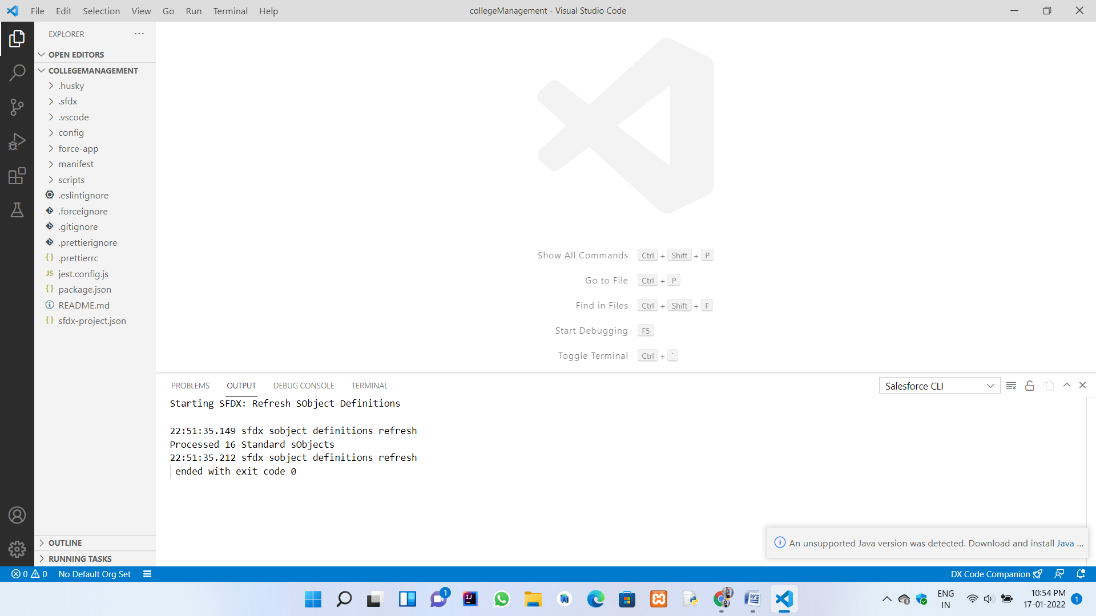

Extensions of the chrome :



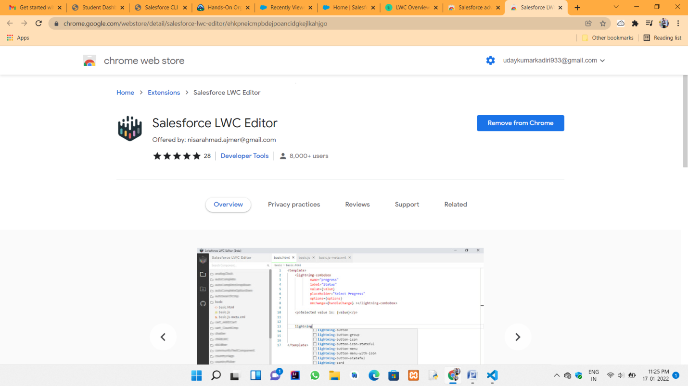

Javascript functions to run in the console in the chrome browser :



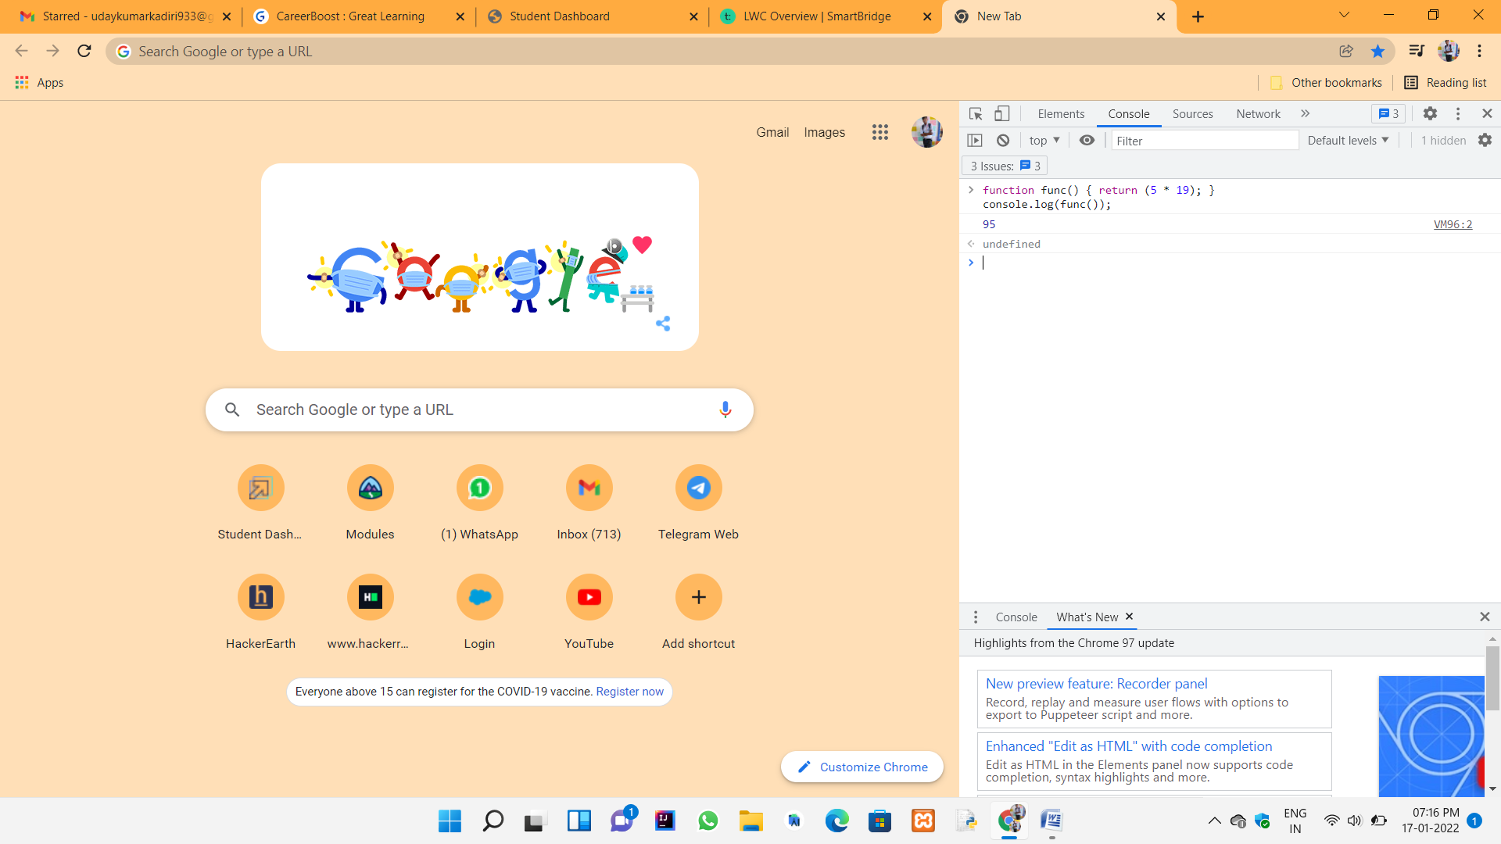



**Day 9 :**

**Topic :**Introduction about java script and explain the different mathods and concepts explained in javascript

**Milestones / Activities :**

Javascript concepts

**Detailed Description :**

**JavaScript is a client side scripting language that runs in a web browser. It has the behavior of functional programming language and concepts of object oriented language.**

Javascript Best Practices using Lightning Component.

JavaScript is a client side scripting language that runs in a web browser. It has the behavior of functional programming language and concepts of object oriented language. While developing lightning component, JavaScript will help us develop the components easily. So, the Lightning developer requires JavaScript knowledge to perform various tasks on client side. Let’s discuss some JavaScript useful tips and tricks to use when using JavaScript in Lightning controllers.

**1. Type conversion v/s Equality (=== vs ==)**

In JavaScript, we have two different kinds of equality operators (‘===’ and ‘==’). It is a good practice to use ‘===’ instead of ‘ ==’. Because the == operator will compare for equality after doing any necessary type conversions. The ===operator will not do the



conversion, so if two values are not the same type === will simply return false. Both are equally quick.

**Using the == operator (Equality)**

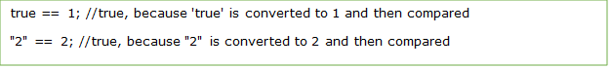

**Using the === operator (Identity)**

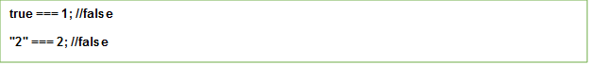

**2. Avoid Global Variables**

In JavaScript, minimize the use of global variables. Global variables and functions can be overwritten by other scripts. So, all variables used in a function should be declared as local variables. Local variable must be declared with var keyword; otherwise they will become global variables.

**3. Undefined vs Null**

JavaScript has additional type which is called “undefined”. undefined means a variable has been declared but has not yet been assigned a value. On the other hand, null is an assignment value. It can be assigned to a variable as a representation of no value.



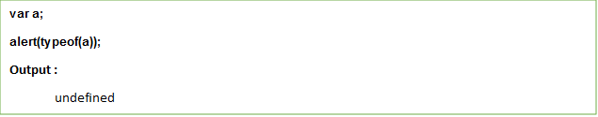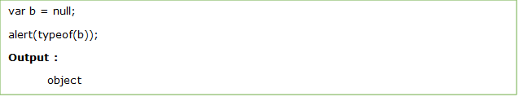

So, the developer must always handle blank, null and undefined.

**4. Use JS Lint**

[JSLint](http://www.jslint.com/) is a code analysis tool. it takes a JavaScript source and quickly scans for any noticeable issues and errors in your code. It’s returns a message describing the problem and an approximate location within the source.

**5.Use Switch Statement to handle multiple conditions**



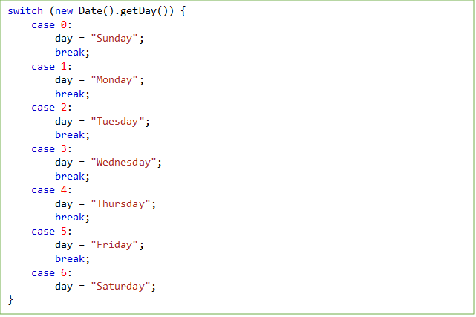

The switch statement is used to perform different actions based on different conditions. the switch statement to select one of many blocks of code to be executed.

**6. Use Curly Braces**

Most of the developers neglect curly braces and semi colon. So, most browsers will misbehave from the original functionality as people think.

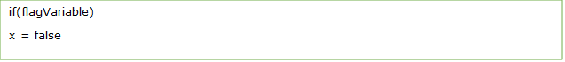

However, Consider this



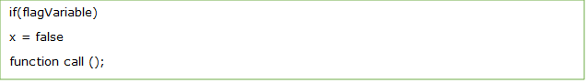

People think the above would be equivalent to

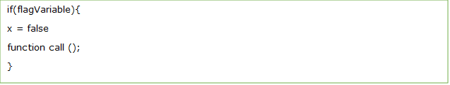

Unfortunately, here it would be wrong. It means

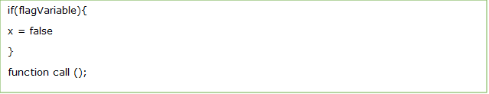

**7. Optimize loops**

If you don’t use loops properly it will hamper your code performance. The common mistake we do in loops is that we read the length attribute of an array at every iteration

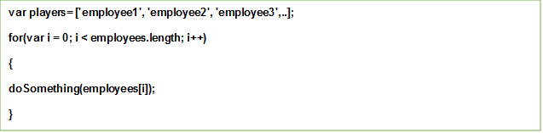



In the above statement, every time the loop runs, JavaScript will read the length of the array. You can avoid that by defining the length value outside the loop and in a different variable

**Better Way:**

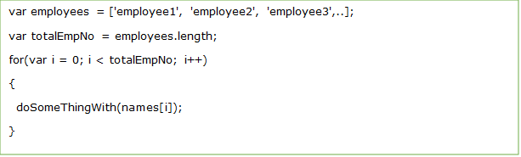

**8. Avoid using eval ()**

Eval function is called “evil” in JavaScript language. Eval takes a String as a argument and JavaScript compiler executes String as JavaScript on run-time.

The code written in eval is executed at run-time and that makes it a security risk

**9. Don’t use JavaScript reserved words**

Don’t use reserved words such as abstract, package, else, false and so on. It will cause you issues when you attempt to run your application. A complete listing of these words can be found at the http://www.w3schools.com/js/js_reserved.asp.

**10. Use {} Instead of New Object ()**

There are multiple ways to create objects in JavaScript. Perhaps the more traditional method is to use the “new” constructor, like so



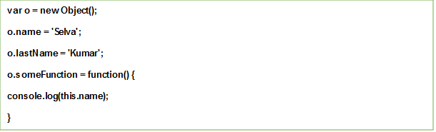

However, this method receives the “bad practice” stamp without being so. Instead, we   can use the much more robust object literal method

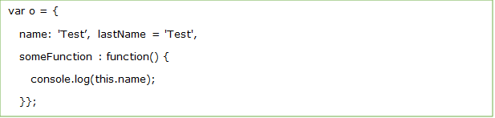



**Screenshots of Milestones / Activities :**

To run the different concepts in the console of the google chrome :

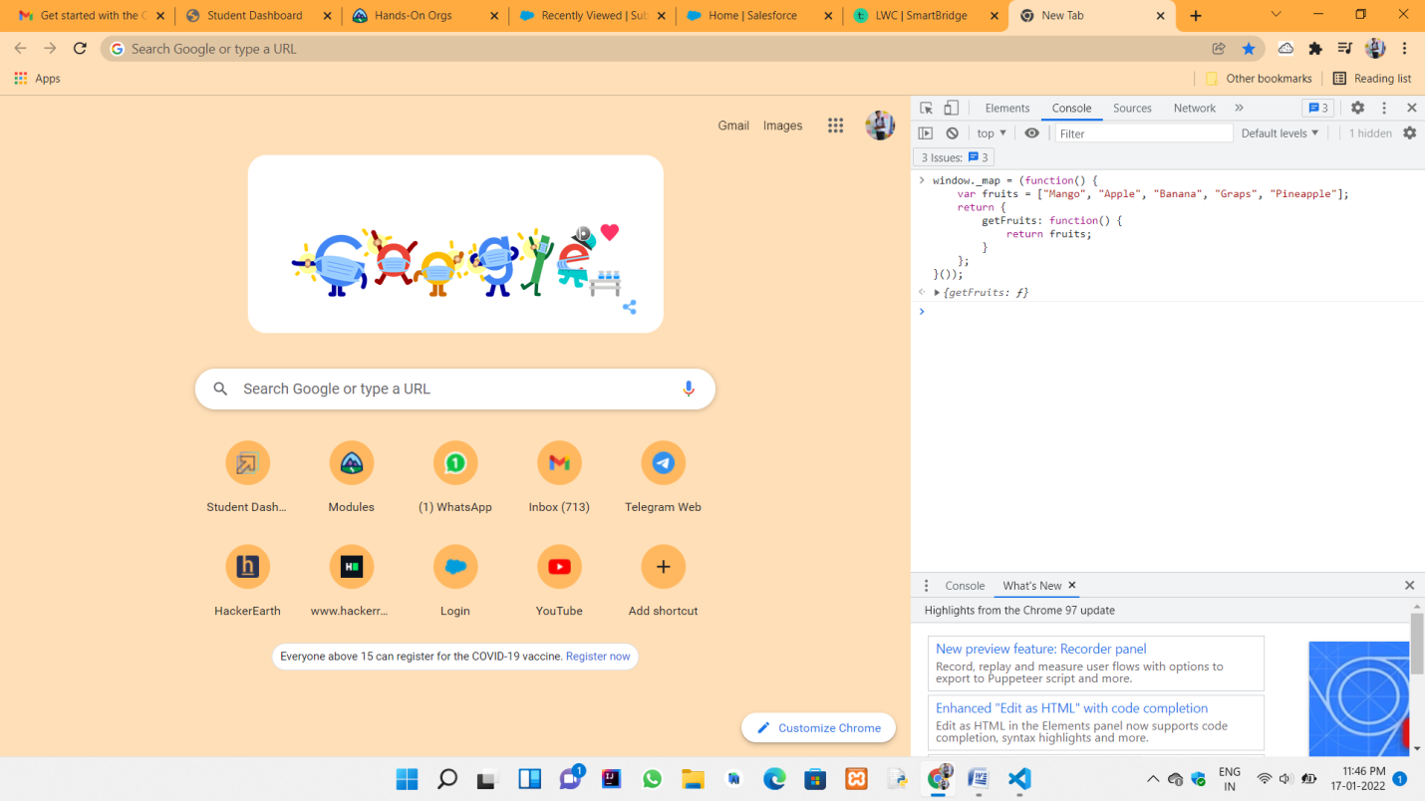

To acess ito the visual studio to the js projects and its help into the lightning web components :



